

The Common European Framework of Reference for Languages: learning, teaching and assessment and the European Language Portfolio and their implementation in the Republic in Macedonia

Jovanka Jovanchevska Milenkoska
University American College Skopje

Abstract

The Council of Europe was formed in 1949 in Strasbourg and it has 47 member-countries. It is an international body working under the European Cultural Convention, which was open for signing in 1954. Its primary emphasis is on democracy, human rights, law and other areas of living within Europe. The goal is to promote the togetherness of the diverse European society, to bring the different cultures closer by accenting the uniqueness of each one, and at the same time by intensifying the need of interconnection of all of them. One of the ways to achieve this is through language. The Council of Europe has formed the Language Policy Division in Strasbourg and the European Centre for Modern Languages in Graz in order to promote the multiculturalism and plurilingualism of the European society. These two official institutions working under the Council of Europe have as their main objectives to enhance the teaching and learning of modern languages to meet the requirements of the modern European citizen.

Keywords: Council of Europe, Europe, citizens, learning

AICEI, 2008, Volume 3, Issue 1, DOI: 10.5281/zenodo.4553978

The Common European Framework of Reference for Languages (CEFR) was first published in 1996 as a draft version, and in 2000 the revised version appeared. It was officially acknowledged the following year, 2001, which was The European Year for Languages. During 2001, a lot of workshops were continuously working and debating on the adoption of the CEFR, and the following years a lot of pilot projects were launched to test the effectiveness of the CEFR and to improve the points which showed not to work as effectively in practice.
The CEFR was published in two languages: English and French. It is not a guide book, it is a book of reference, a descriptive tool which does not preach on the educational values and methodologies, but it only describes the choices of teaching and learning and the ways of effective assessment.
The idea that languages are an important tool in reaching mutual understanding and coherence among the European countries dates back from the 1970s. The two main streams of linguistic methodology which were prevalent the whole century – structuralism and generativism – and were concerned with some more theoretical issues such as the nature and the production of language, showed to be impractical, the linguists turned to the more practical approaches of learning and teaching. The great breakthrough was the communicative approach. It is a methodology which approves of everything which is efficient in order to achieve communication. The learner’s communicative needs were put in the first place, and other terms started to gain more awareness: self-assessment, learning how to learn, learner’s autonomy, self-directed language learning etc.

In the last three decades of the previous century, a lot of workshops and seminars were organized under the orchestration of the Council of Europe, which dealt with the new learning approaches, with the new ways of determining the threshold level in foreign language learning and with many other issues. At the beginning of the 1990s the idea of creating a European Language Portfolio was conceived at one of these seminars (Rüschlikon, Switzerland, 1991), and later on the CEFR was produced.

The contents of the CEFR

The CEFR is a reference book for every single individual involved in the process of modern language learning. The three basic principles that the CEFR requires out of language learning are that it should be: comprehensive, transparent and cohesive. It does not prescribe and impose methodologies, but it offers a common methodology, terminology and scale of descriptors for determining the level of competence of the learner.
The layout of the book is organized in nine chapters, each one dealing with a different issue. At the beginning the aims and the objectives of the Council of Europe language policy are neatly displayed. These have a lot to do with the goal with which the Council of Europe was formed: human rights and mutual understanding and creating a multinational society which will override the differences among the member states and will improve communication and tolerance among the cultures. This is largely connected to the plurilingualism, which is a very clearly displayed aim in the new language-learning tendencies. Basically, plurilingualism differs from multilingualism, which is the knowledge of a number of languages, or the co-existence of different languages in a given society. The plurilingualism emphasizes the cultural context, aiming at the fact that one should not keep the knowledge of more languages separated in their mind, but that one should use all their knowledge to build up a communicative competence in all languages. The experiences of different language-learning processes should not be kept apart, but used adequately and in all instances to promote the communication.
The CEFR is primarily intended for three different goals: planning of language learning programmes, planning of language certification and planning of self-directed learning.
The action-oriented approach is separately discussed in a chapter, and it explains headlines such as: the general competences of an individual, the communicative language competences; language activities (reception, production, interaction and mediation); domains (public, personal, educational, occupational); tasks, strategies and texts; language assessment and others.
The Common Reference Levels are one of the most important theme dealt in the CEFR, since they are accepted as the main guidelines in the assessment of the speaker’s knowledge of one language. The basic division is in three different levels: Basic User, Independent User and Proficient User, which are themselves divided into two sublevels each, as shown in the next picture diagram:

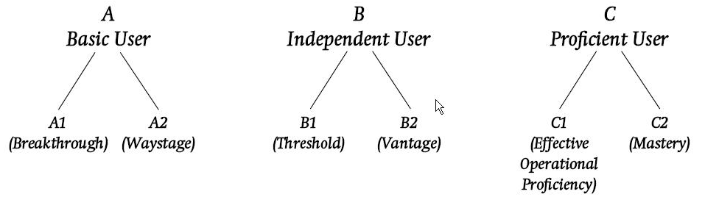 Each of the levels is carefully determined through a number of extensive descriptors in order to present the language user’s competence as it is in reality. There is also the possibility of flexibility: each user of the level descriptors is allowed to insert a midlevel, such as B1+ or C1+ whenever it is needed.
There is also given a proficiency scale, which is created to explain the use of the grades (1-9) while implementing examinations.
The practical strength of the CEFR is in the versatility of the displayed themes, especially in the explanation of the communicative language activities and strategies, which are the number one product of the late 20th century in language learning. Many of the communicative activities are shown, which are very much contributive to the user of the CEFR. Paralinguistic and non-verbal communication is introduced as a powerful means for achieving successful communication. These areas include: gestures, body-language, eye-contact, facial expressions, physical pointing, extra-linguistic speech sounds (sh, ugh) etc.
In the chapter about the user/learner’s competences, the sociolinguistic factors of today’s living are shown and also their influence on the process of language learning and language teaching. The sociocultural knowledge is an aspect of the knowledge of the world and is likely to lie outside the learner’s previous experience and may as well be distorted by stereotypes. Those stereotypes may be overcome by developing an intercultural awareness and understanding of the target culture. Skills and know-how is a part of the chapter dealing with social skills, leisure skills, professional skills, existential competence, study skills, heuristic skills and the communicative language competence. The linguistic competence is separately shown (lexical, grammatical elements), and this is especially applicable for language teachers in their everyday work, as reference to how much metalanguage should be used in their work. The pragmatic competences, such as discourse competence, text design and other themes are explained, as well as the functional competency (there are descriptors on the spoken fluency and the propositional precision).
In the chapter on language learning and teaching some of the preferable methodologies are captured in their essence, and the advantages and disadvantages of their use are presented. It is very important to note that each of these presentations does not require its use. Mainly, it is the teacher/learner’s own approach towards teaching/studying; these choices are given not as prescriptions, bus strictly as descriptions of the available possibilities. (E.g. The errors’ and mistakes’ correction has puzzled language professionals for a long time; it is rather difficult for a teacher to choose the correct and most efficient way of error correction. In the CEFR the error correction is a problem displayed in order to attract the attention of the language professionals and to support them in choosing the most effective way of dealing with this problem.).
The affective factors are given to show that language learning depends a lot on the environment in which it is learnt. Some psychological factors, which rely largely on the external factors, such as self-esteem, involvement and motivation, and attitude, are crucial to developing the learner’s competences.
The language professionals are especially aided by the CEFR in the curriculum design, which can be a very demanding job, and intriguing as well. There are a lot of variations, and most of these are shown in the chapter on linguistic diversification and the curriculum. The types of assessment (including teacher assessment) are valuable resources for presenting the truthful competences, and some different criteria from different European countries are discussed.
All in all, the CEFR has opened up a new era in the history of modern language teaching and learning in Europe by constituting the first language policy tool that truly embraces all modern languages. Its contributions are extensive in many areas: methodology, terminology, assessment, learning and others.

The European Language Portfolio: successful application of the CEFR

The European Language Portfolio (ELP) is a concept of application of the CEFR. The creation idea stems from the beginning of the 1990s, but its practical involvement in the life of the European citizen in all areas commences with the adoption of the CEFR in 2001. Pilot projects in 15 European countries preceded its official entry into practice, all of which showed to be successful.
The ELP is one of the first practical applications of the CEFR and it has helped to spread many of the CEFR’s basic ideas. It has become clear that the documentation/presentation aspect of the ELP has the potential to play the a key role throughout Europe in the attempt to introduce transparency and coherence into the description and documentation of proficiency in modern languages. Learners, teachers and parents, schools as well as employers and educational systems may benefit from it. Another fact is that the ELP has gained a lot of popularity and recognition throughout the years and its commercial applicability can improve the status and the relevance of its users. It can also trigger and support changes in the field of teaching practice, curriculum design and assessment, although it is mostly aimed at the learner.
The ELP is the property of the learner and it accompanies learners throughout their learning process from the earliest ages. It enables users to:

- record their language skills and experiences in using different languages, stays in the target language countries and contacts with languages other than their mother tongue;
- develop their learner’s autonomy by conscious self-assessment of the results they have reached and the level of proficiency they want to reach;
- achieve the abilities to be language-efficient in the plurilingual environment – to be able to maintain a satisfactory level of communication in as many environments as possible.

Structure of the ELP

The word portfolio which is contained in the ELP may prompt many of us to think of it as an association of the world of art – sample work of an artist with the purpose of presentation of the artist’s work so far. Although the ELP is much more than this, this parallel does show partly the nature of the ELP, the difference being in that the ELP treats the language as a mastery which can be presented in a similar fashion.
The Principles and Guidelines approved by the Council of Europe (DGIV/EDU/LANG (2000) 3) define the three components of the ELP as follows:

- The Language Passport section provides an overview of the individual’s proficiency in different languages at a given point in time; the overview is defined in terms of skills and the common reference levels in the Common European Framework; it records formal qualifications and describes language competencies and significant language and intercultural learning experiences; it includes information on partial and specific competence; it allows for self-assessment, teacher assessment and assessment by educational institutions and examinations boards; it requires that information entered in the Passport states on what basis, when and by whom the assessment was carried out. To facilitate pan-European recognition and mobility a standard presentation of a Passport Summary is promoted by the Council of Europe for ELPs for adults.

- The Language Biography facilitates the learner’s involvement in planning, reflecting upon and assessing his or her learning process and progress; it encourages the learner to state what he/she can do in each language and to include information on linguistic and cultural experiences gained in and outside formal educational contexts; it is organized to promote plurilingualism, i.e. the development of competencies in a number of languages.

- The Dossier offers the learner the opportunity to select materials to document and illustrate achievements or experiences recorded in the Language Biography or Passport.

Since the ELP’s use was adopted, there have been a lot of versions of the ELP that appeared on the scene. Many of them are different according to the countries where they stem from, the different contexts, the different purposes etc. The Council of Europe has been very open-minded in accepting many versions of the ELP. They just need to be assessed by the Council of Europe’s Validation Committee if they are to bear the Council of Europe logo. This diversity is welcome because it shows the individual approach of individual countries and authorities towards understanding the CEFR.
At the 6th annual international ELP seminar for national ELP contact persons held in Moscow in autumn 2005 it was stated as a fact that an increasing number of non-validated Language Portfolios are now in use. Many of these models conform to the Principles and Guidelines of the CEFR, but have for some reason never been submitted for validation, e.g. versions in minority languages.
A number of Portfolios on the market use concepts and ideas of the ELP and CEFR without due acknowledgment and without following the Common Principles and Guidelines. It was decided that action needs to be taken on this issue.
- Electronic ELP models
A first electronic ELP was validated in 2005. The EAQUALS/ALTE model for adult learners, initially validated as paper version in 2000, has been issued with the accreditation number: 06.2000 electronic version. Two further electronic ELP models have been submitted for validation and a fully interactive model stored on a central host was being piloted in the Netherlands.
Electronic dissemination of the ELPs as well as electronic support for learners and teachers are increasing. The Common Principles and Guidelines might need to be reinterpreted and/or adapted in response to these developments.

The functions of the ELP

The ELP has two functions:

- The pedagogic function

  - Enhance the motivation of the learners
- to improve their ability to communicative in different languages,
- to learn additional languages,
- to seek new intercultural experiences.
  - Incite and help learners to
- reflect their objectives, ways of learning and success in language learning,
- plan their learning,
- learn autonomously.
  - Encourage learners to enhance their plurilingual and intercultural experience, for example through
- contacts and visits,
- reading,
- use of the media,
- projects.
- The documentation and reporting function
The European Language Portfolio aims to document its holder's plurilingual language proficiency and experiences in other languages in a comprehensive, informative, transparent and reliable way. The instruments contained in the ELP help learners to take stock of the levels of competence they have reached in their learning of one or several foreign languages in order to enable them to inform others in a detailed and internationally comparable manner. There are many occasions to present a Language Portfolio which is up to date, for example a transfer to another school, change to a higher educational sector, the beginning of a language course, a meeting with a career advisor, or an application for a new post. In these cases the ELP is addressed to persons who have a role in decisions which are important for the owner of the Language Portfolio. A learner may also be interested in having such documentation for him-/herself.
In its reporting and pedagogical functions, the ELP is designed to support four of the Council of Europe’s key political aims: the preservation of linguistic and cultural diversity, the promotion of linguistic and cultural tolerance, the promotion of plurilingualism, and education for democratic citizenship.

On the next page, the self-assessment grid in English is shown. This grid is the principle means for determination of a learner’s competence in the ELP. It was first presented in the CEFR.

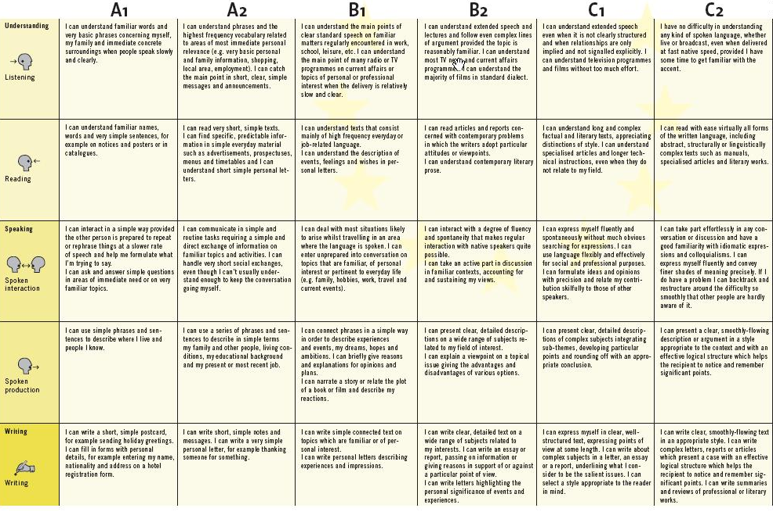
The application of the CEFR and the ELP in the Republic of Macedonia

Based on the Interim report published as a summary of the 6th annual international ELP seminar for national ELP contact persons held in Moscow in autumn 2005, the following overview of reported activities was produced:

Albania no activity reported | Lithuania
Andorra no activity reported | Luxembourg no activity reported
Armenia | Malta no activity reported
Austria | Moldova
Azerbaijan no new information | Netherlands
Belarus | Norway
Belgium | Poland
Bosnia & Herzegovina no activity reported | Portugal
Bulgaria | Romania
Croatia | Russian Federation
Cyprus | San Marino no activity reported
Czech Republic | Serbia and Montenegro
Denmark | Slovakia
Estonia | Slovenia
Finland | Spain
France | Sweden
Georgia | Switzerland
Germany | The Former Yugoslav Rep. Macedonia nor
Greece | Turkey
Hungary | Ukraine no activity reported
Iceland | United Kingdom
Ireland | INGOs
Italy | CERCLES
Latvia | Eaquals/Alte
Liechtenstein no activity reported | European Language Council
As can be seen from the table, no activity until 2005 was reported.
In 2006, the British Council in Macedonia, working together with local partners, the IIZ-DVV Skopje (Institute für Internationale Zusammenarbeit Deutschen Volkshochschul - Verbandes) and MAQS (Macedonian Association for Quality Language Services), to support the introduction of the European Language Portfolio in Macedonia.
The 06.2000 version of the EAQUALS (The European Association of Quality Language Services)/ALTE (Association of Language Testers of Europe) ELP for adults was translated into Macedonian and Albanian and was published in a 4-language portfolio (English/German/Macedonian/Albanian). For this purpose, in April 2006 a Conference on the ELP and the CEFR was organized for an audience of 65 teachers of English and German in the state and private sectors, including language advisors from the Ministry of Education, as well as university and secondary school teachers (an audience of teachers teaching 16+).
In 2007, a workshop was organized, focusing on the implementation of the ELP and the practical implications for the teachers and students.
In 2008 there are still on-going promotions and implementation of the ELP, as well as an effort for the ELP for teenagers to be published.

The implementation of the CEFR and the ELP in Macedonia will not happen over night. The primary task is to get language teachers acquainted with these documents. That is partly a task of the official government institutions and partly a responsibility of language teachers to follow the world and European trends in language teaching and to try to implement as much as they can of the newly introduced tendencies in their work. This will help to get pupils and students involved in the practice of keeping their own personal ELP active, and thus to improve their language competences and performance.
The Macedonian learner is definitely capable of following the EU tide of language learning policies, and not only will these improve their performance in the other countries in Europe, but they will as well create a more direct approach to the EU institutions.
References

A Common European Framework of reference for Languages: Learning, teaching, assessment, Council of Europe (2001) Cambridge University Press.

Bailly, S. et al A Common European Framework of Reference for Languages: Learning, Teaching, Assessment – A Guide for Users. Strasbourg: Council of Europe, 2001

Council of Europe, 2000: European Language Portfolio (ELP): Principles and Guidelines. Strasbourg: Council of Europe. (Document DGIV/EDU/LANG (2000) 33)

Goullier, F. Tools for Language Teaching, Common European Framework and Portfolios, Council of Europe, Didier 2007

http://www.britishcouncil.org/macedonia-english-elp.htm

Little, D., Perclova. R., The European Language Portfolio: A Guide for Teachers and Teacher trainers, Council of Europe

Schärer, R., Rapporteur, G. European Language Portfolio: Interim Report 2005 with Executive Summary, The Council of Europe, Language Policy Division, Strasbourg 2005

Schneider, G., Lenz, P.: A Guide for Developers of European Language Portfolios. Strasbourg: Council of Europe, 2001

